Chapter No. 03

System Design

System design is a mechanism to transform user requirements into some suitable form, which helps the programmer in software coding and implementation. It deals with representing the requirement as described in software requirement specification (SRS). Furthermore, make its activity, state machine, sequence and deployment architectures by illustrated various diagrams that discussed below in detail.

<https://www.javatpoint.com/software-engineering-software-design>

Design Methodology

The application is designed using bottom up methodology, in which we solved smaller problems and integrate it as complete. This methodology is really suitable for Functional programming approach and as we known earlier our application is build by using React Native & React JS.

Application Interface Design

In designing, application interface is a significant segment. The interaction of the user with an application is important and a non-conformed design leave a bad impression. Taking everything in mind, we designed the interface of Smart Access as much interactive possible and user-friendly by using Figma, a collaborative web application for interface design. These are the following prototype images of the application.

Unified Modeling Language Diagrams

These are the following unified modeling language (UML) diagrams used to visually represent the architecture design of an android based application called Smart Access.

Activity Diagram

This is essentially a flowchart that represent the activities performed by the application. The illustration of the following diagram is given below.

State Machine Diagram

This is almost similar to the activity diagram but describes in-depth all the states and transitions for a single object. It represents application behavior upon the user and other external actions. These are the following illustrative state machine diagrams of the application.

Signup State Machine Diagram

Given below is the following illustrative representation of signup panel state machine diagram.

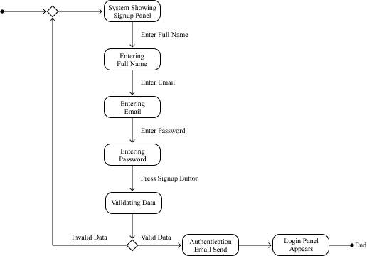

Login State Machine Diagram

Given below is the following illustrative representation of login panel state machine diagram.

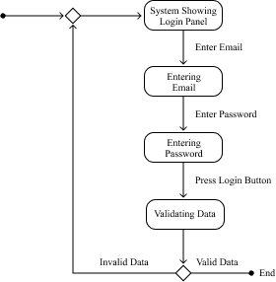

Forgot Password State Machine Diagram

Given below is the following illustrative representation of forgot password state machine diagram.

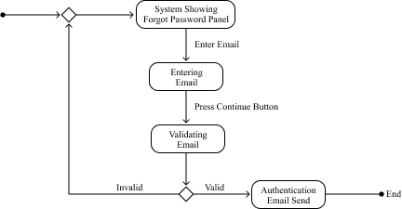

Register Service State Machine Diagram

Given below is the following illustrative representation of register service state machine diagram.

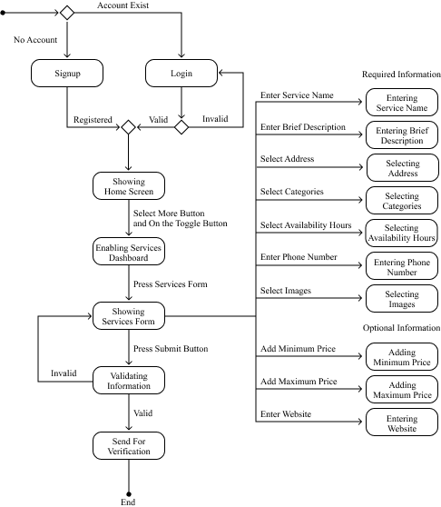

Update Service State Machine Diagram

Given below is the following illustrative representation of update service state machine diagram.

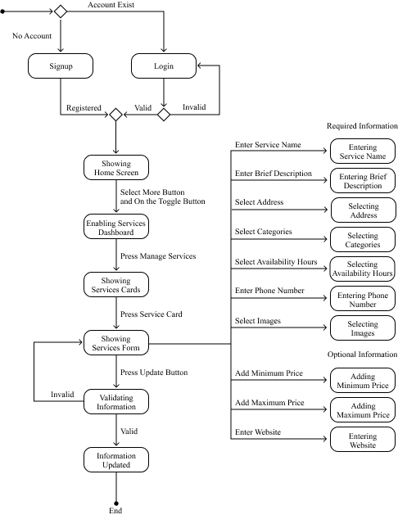

Delete Service State Machine Diagram

Given below is the following illustrative representation of delete service state machine diagram.

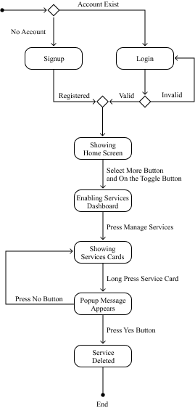

Verified or Pending Service State Machine Diagram

Given below is the following illustrative representation of verified or pending service state machine diagram.

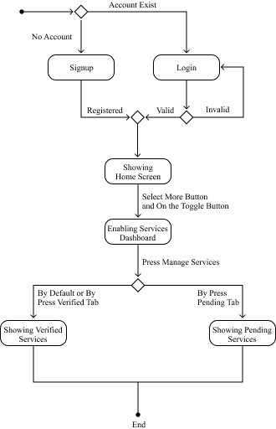

View Service State Machine Diagram

Given below is the following illustrative representation of view service state machine diagram.

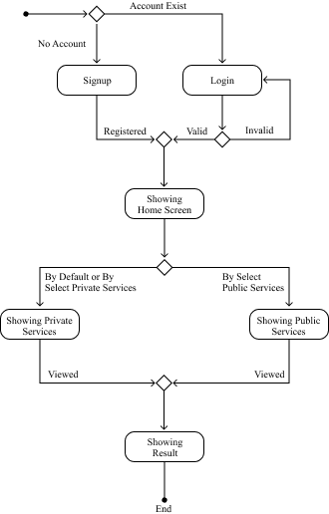

Search Service State Machine Diagram

Given below is the following illustrative representation of search service state machine diagram.

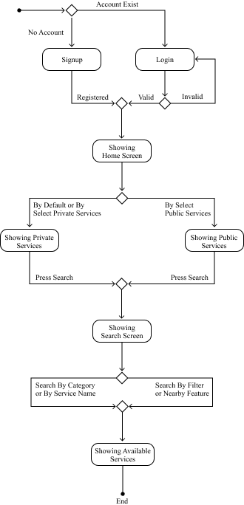

Recommended Services State Machine Diagram

Given below is the following illustrative representation of recommended services state machine diagram.

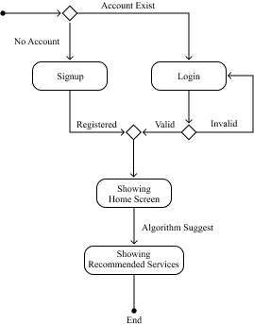

Chat Bridge State Machine Diagram

Given below is the following illustrative representation of chat bridge state machine diagram.

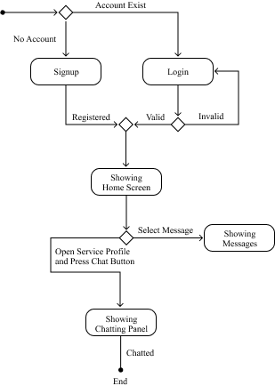

Admin Panel State Machine Diagram

Given below is the following illustrative representation of admin panel state machine diagram.

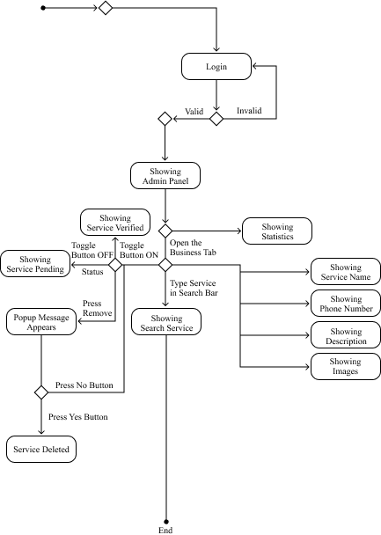

Sequence Diagram

This is an interaction diagram that represents the order collection of objects working together as well as visually representation of the requirement uses cases previously discussed. These are the various sequence diagrams illustrate below.

Signup Sequence Diagram

Given below is the following illustrative representation of signup panel sequence diagram.

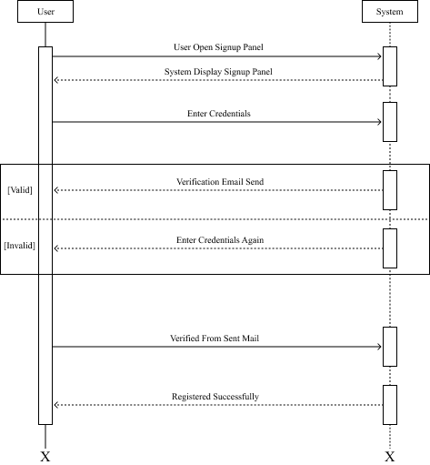

Login Sequence Diagram

Given below is the following illustrative representation of login panel sequence diagram.

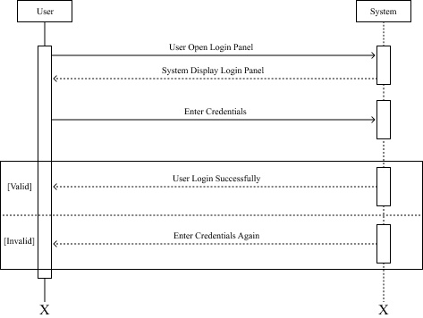

Forgot Password Sequence Diagram

Given below is the following illustrative representation of forgot password sequence diagram.

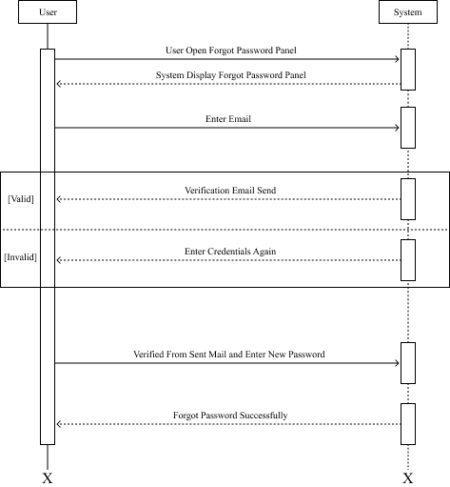

Register Service Sequence Diagram

Given below is the following illustrative representation of register service sequence diagram.

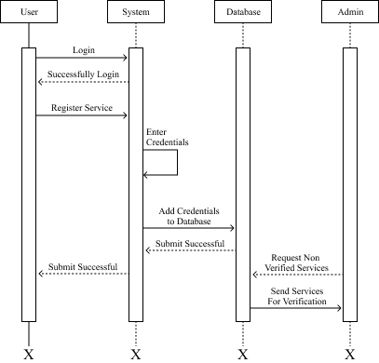

Update Service Sequence Diagram

Given below is the following illustrative representation of update service sequence diagram.

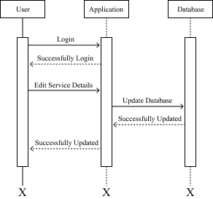

Delete Service Sequence Diagram

Given below is the following illustrative representation of delete service sequence diagram.

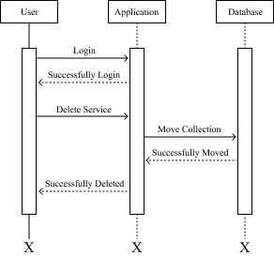

Verified or Pending Service Sequence Diagram

Given below is the following illustrative representation of verified or pending service sequence diagram.

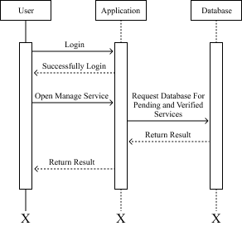

View Service Sequence Diagram

Given below is the following illustrative representation of view service sequence diagram.

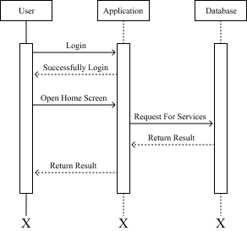

Search Service Sequence Diagram

Given below is the following illustrative representation of search service sequence diagram.

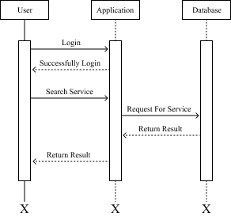

Recommended Services Sequence Diagram

Given below is the following illustrative representation of recommended services sequence diagram.

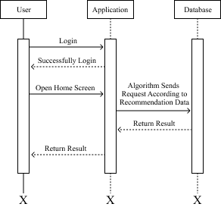

Chat Bridge Sequence Diagram

Given below is the following illustrative representation of chat bridge sequence diagram.

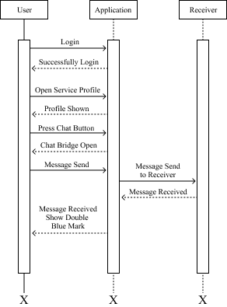

Admin Panel Sequence Diagram

Given below is the following illustrative representation of admin panel sequence diagram.

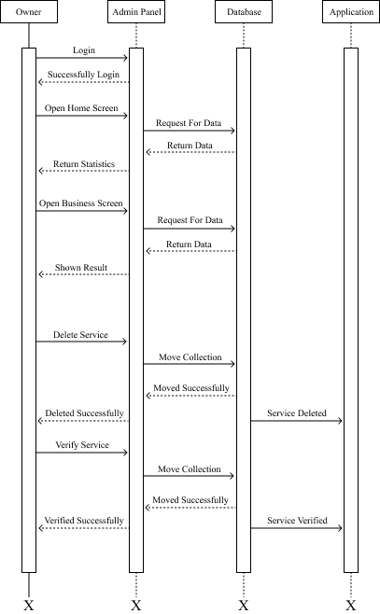

System Design View Perspective Models

There are two main types of system design models in the perspective of the view. The logical design view and the physical design view. The further explanation of these view with respect to the application is discussed below.

Logical Design View

The application is used Firebase, a cloud-hosted NoSQL realtime database that stored data in the form of Javascript Object Notation (JSON). That’s why the logical design view is not possible because it consists of class and entity relationship diagrams.

Physical Design View

This design view represents the end deployment of the application. It helps the engineers as a visual guide to deployed the system accordingly. In this the deployment diagram is used which shows the execution architecture with software and hardware of the application.

Deployment Diagram

Given below is the following deployment illustration of the Smart Access, an android based application.

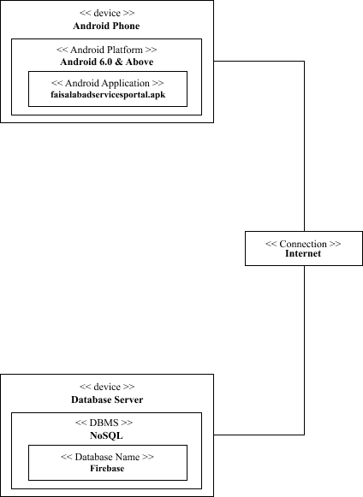

Summary

This chapter talks about the system design, the methodology used in the designing process, the application interface prototype and various unified modeling language diagrams like activity, state machine and sequence diagrams. Furthermore, the chapter also discussed about the system design view perspective models like logical view and physical view models with deployment diagram.